Web Application Security Basics

1. Introduction
Web applications are widely used to provide online services and manage sensitive user data. However, improper input validation and insecure coding practices can expose applications to various security vulnerabilities. This assessment was conducted in a controlled laboratory environment using Damn Vulnerable Web Application (DVWA) to understand common web application attacks and their mitigation techniques.
The assessment focused on identifying two common vulnerabilities: Reflected Cross-Site Scripting (XSS) and SQL Injection (SQLi). Burp Suite was used to intercept and analyze HTTP requests between the client and the web application.

2. Objectives
The objectives of this assessment were:
- To understand the fundamentals of web application security testing.
- To identify Reflected Cross-Site Scripting vulnerabilities.
- To identify SQL Injection vulnerabilities.
- To use Burp Suite to intercept and analyze HTTP requests.
- To recommend mitigation strategies for the identified vulnerabilities.

3. Tools Used
- Kali Linux
- DVWA (Damn Vulnerable Web Application)
- Burp Suite Community Edition
- Docker
- Mozilla Firefox

4. Environment Setup
The testing environment was configured in a virtual laboratory using Kali Linux. DVWA was deployed using Docker and accessed locally through a web browser. Burp Suite was configured as an intercepting proxy to analyze web traffic.
Environment details:
- Operating System: Kali Linux
- Target Application: DVWA
- Deployment Method: Docker Container
- Browser: Mozilla Firefox
- Proxy Tool: Burp Suite Community Edition
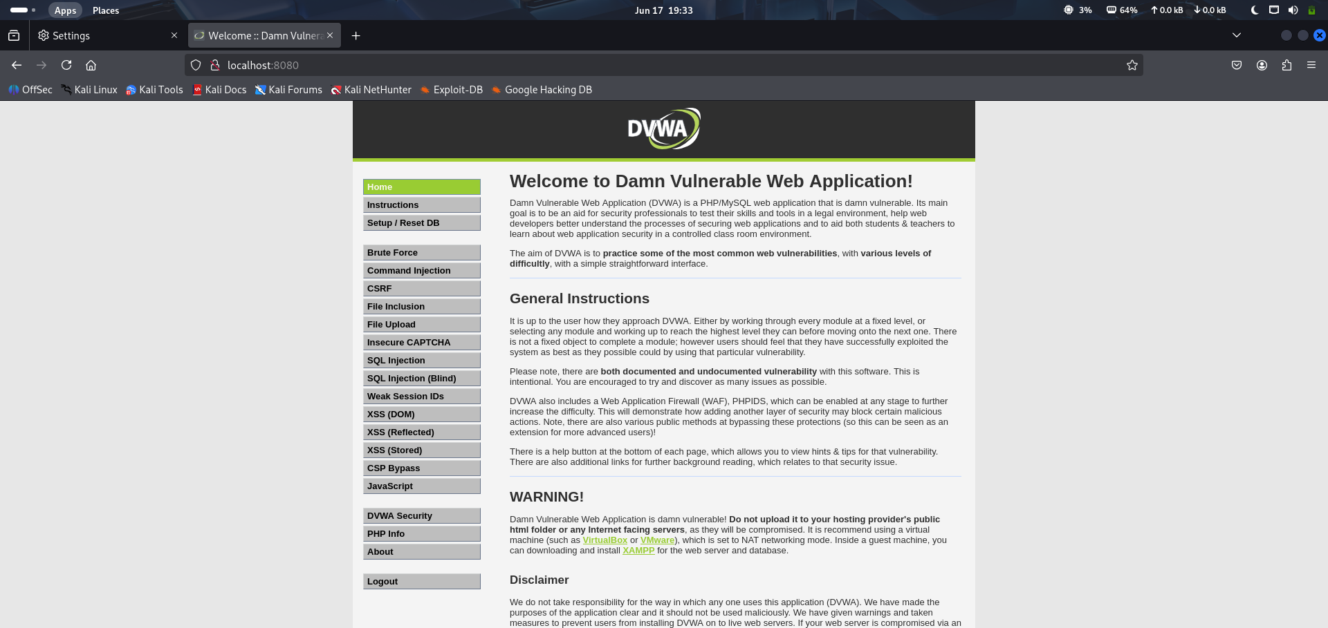

5. Methodology
The assessment followed the steps below:
- DVWA was deployed using Docker.
- The application security level was configured to "Low".
- Burp Suite was configured as an intercepting proxy.
- Firefox was configured to route traffic through Burp Suite.
- Requests and responses were intercepted and analyzed.
- Vulnerability testing was performed in a safe laboratory environment.
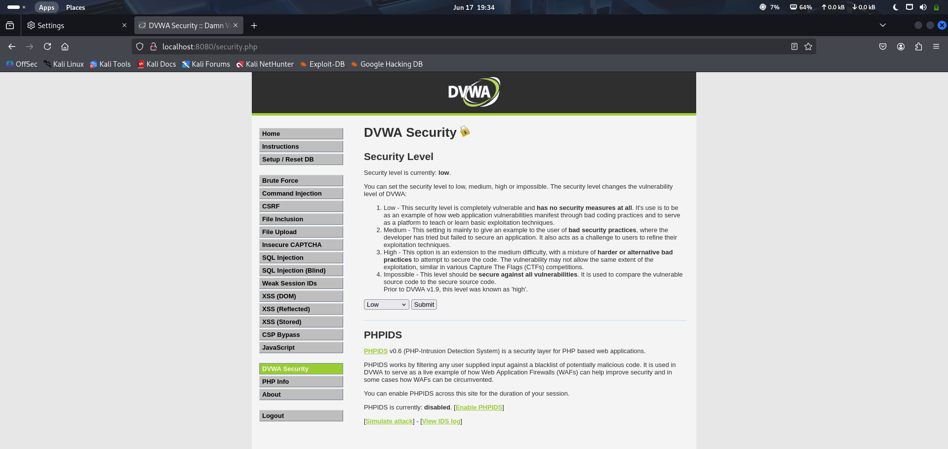
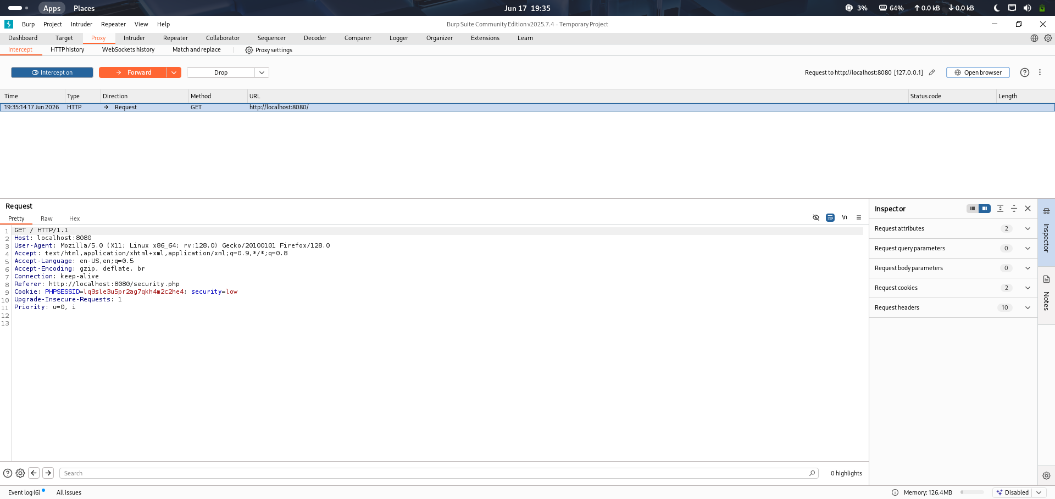

6. Finding 1: Reflected Cross-Site Scripting (XSS)
Description
Reflected Cross-Site Scripting occurs when user-supplied input is included in a web application's response without proper validation or output encoding. As a result, malicious scripts can be executed within the victim's browser.
Test Procedure
The "XSS (Reflected)" module in DVWA was used to test the application.
Payload used:
<script>alert('XSS')</script>
The request was intercepted using Burp Suite before being forwarded to the application.
Observation
After the request was processed, the browser executed the injected JavaScript code and displayed an alert message, confirming the presence of a Reflected XSS vulnerability.

Impact
- Execution of arbitrary JavaScript code
- Session hijacking
- Theft of sensitive information
- Redirection to malicious websites
- Modification of webpage content

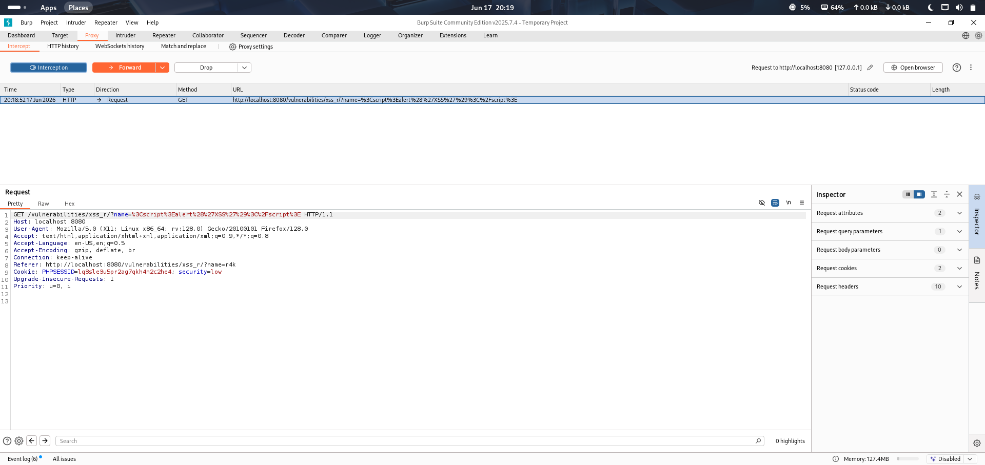

7. Finding 2: SQL Injection
Description
SQL Injection occurs when user input is incorporated into database queries without proper validation or parameterization. Attackers can manipulate queries to access unauthorized information.

Test Procedure
The "SQL Injection" module in DVWA was used to test the application.
Payload used:
1' OR '1'='1
The request was intercepted using Burp Suite before being forwarded to the application.
Observation
The application returned multiple user records instead of a single record, indicating that the SQL query logic had been altered by the injected payload.
Impact
- Unauthorized access to sensitive data
- Authentication bypass
- Data manipulation or deletion
- Compromise of database integrity
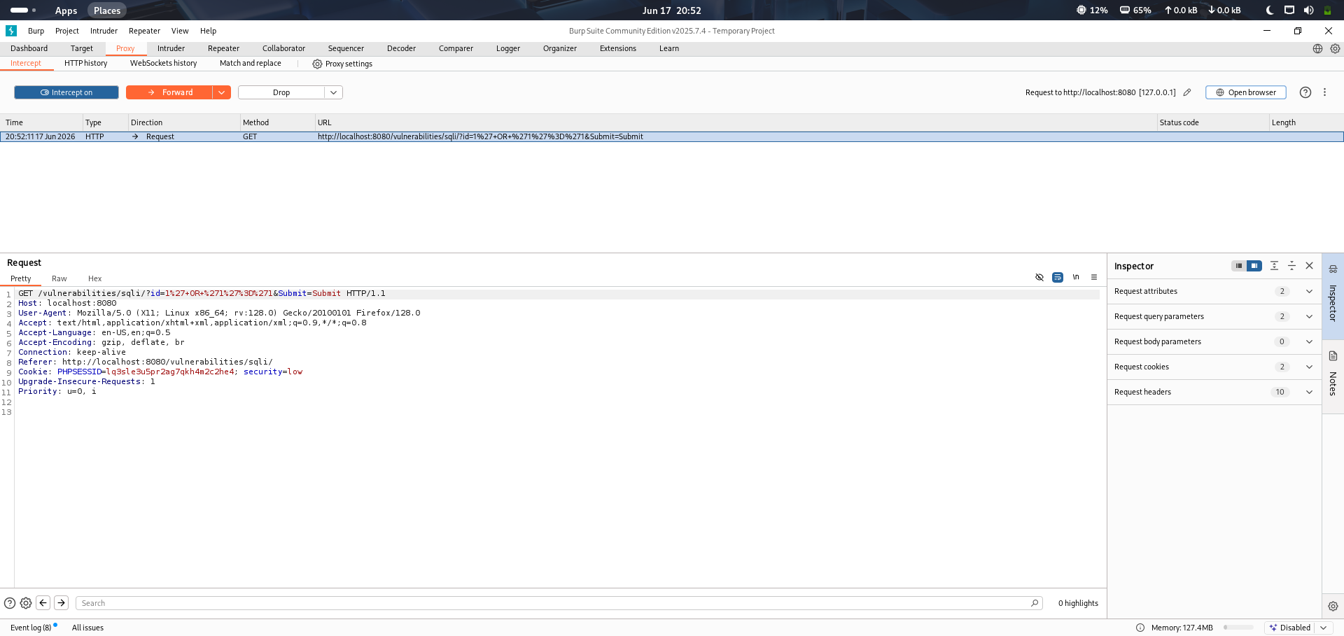

8. Mitigation Recommendations
Reflected Cross-Site Scripting (XSS)
- Validate and sanitize user input.
- Encode output before rendering it in the browser.
- Implement Content Security Policy (CSP).
- Use secure frameworks that automatically escape output.

SQL Injection
- Use parameterized queries or prepared statements.
- Avoid dynamic query construction.
- Validate user input using allowlists.
- Apply the principle of least privilege to database accounts.
- Use a Web Application Firewall (WAF).

9. Conclusion
This assessment demonstrated the identification of common web application vulnerabilities in a controlled environment using DVWA and Burp Suite. Reflected Cross-Site Scripting and SQL Injection vulnerabilities were successfully identified and analyzed. The exercise emphasized the importance of secure coding practices, input validation, output encoding, and parameterized database queries to protect web applications from common attacks.

